**Programming mistakes**

Q1: Undeclared Variables.

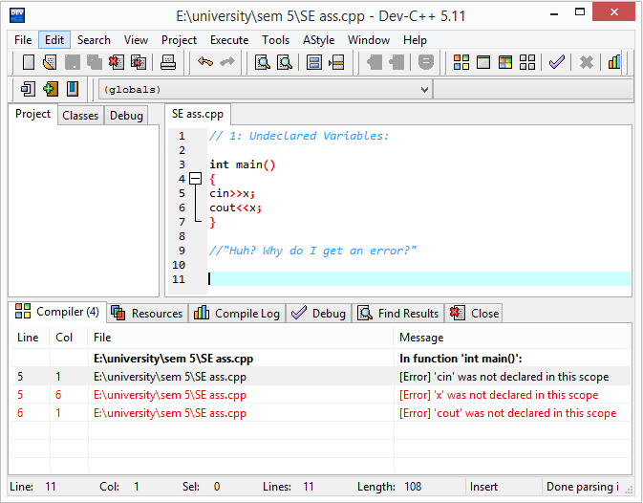

Ans: Because “x” was not declared.

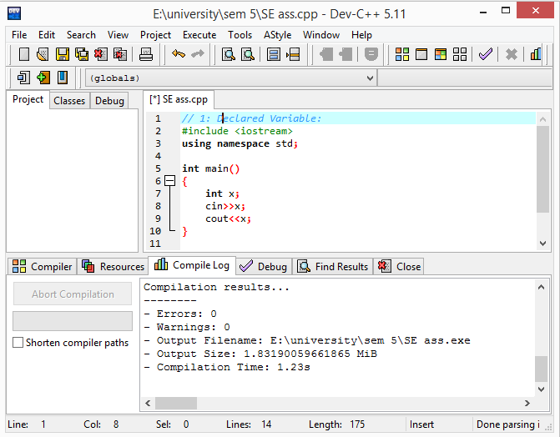

Q2: Uninitialized variables.

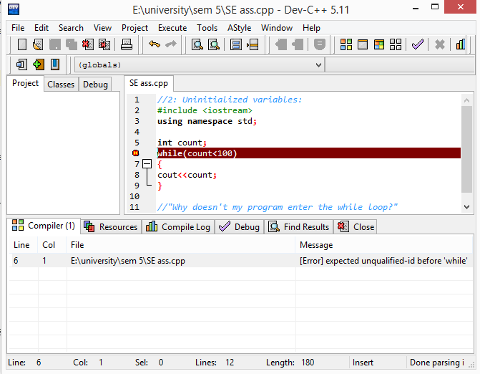

Ans: Because “count” was not initialized.

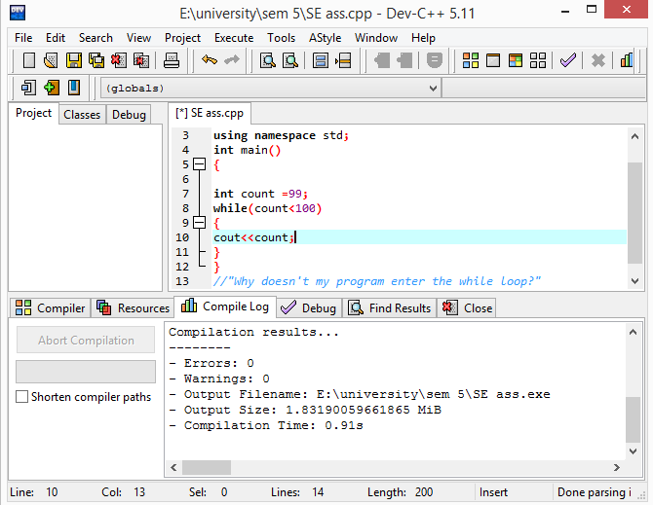

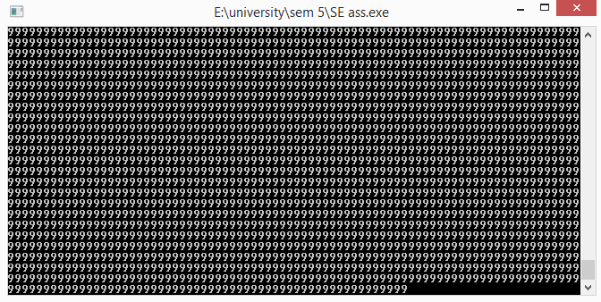

Ans:And there was increment in the loop.

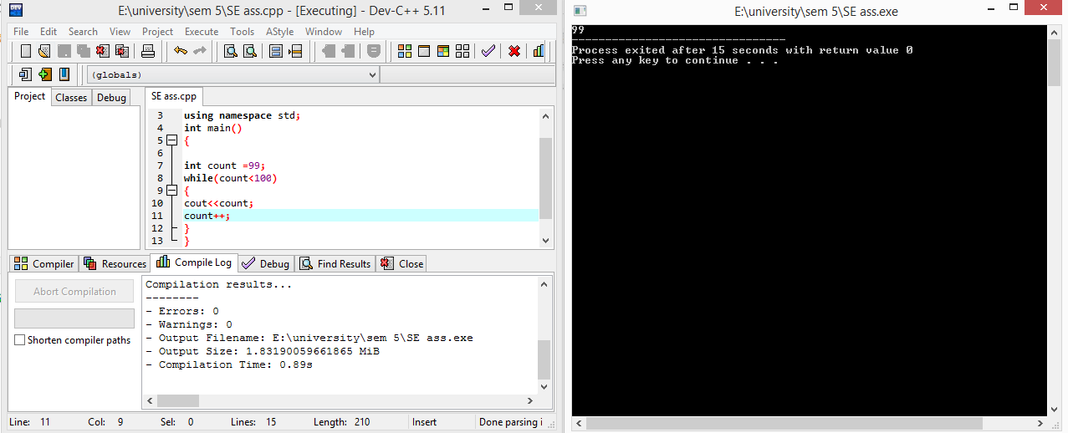

Q3: Setting a variable to an uninitialized value:

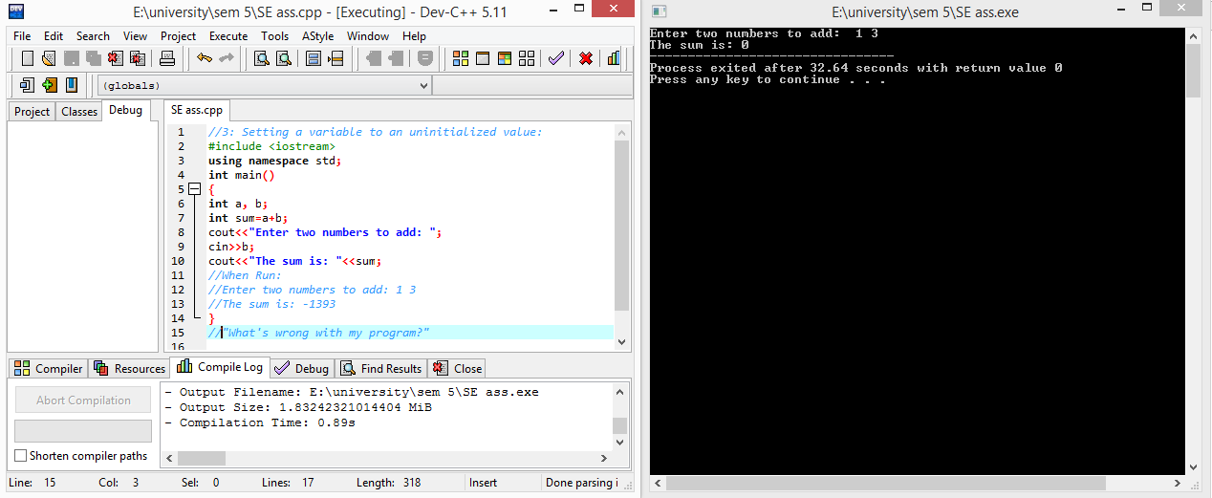

Ans:It’s not taking the value of “a” and it’s taking sum before the input.

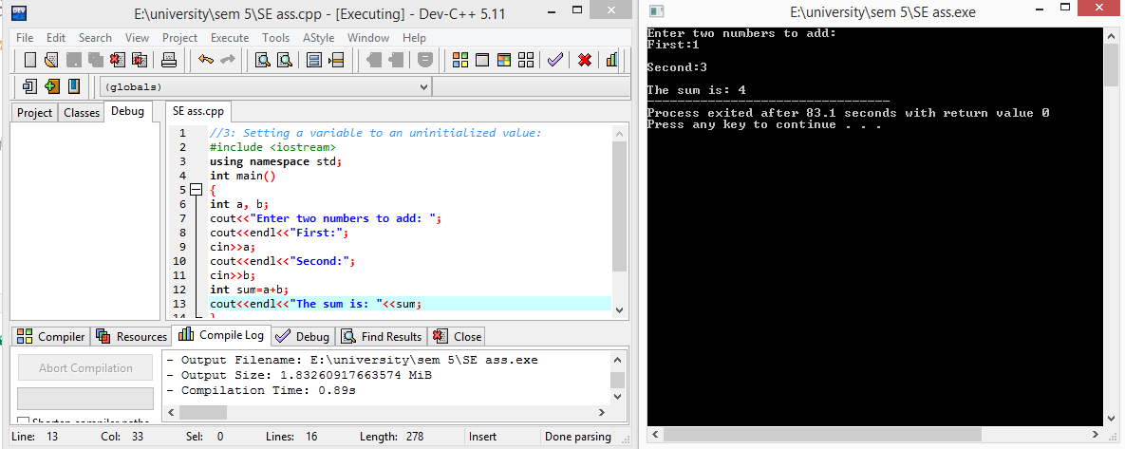

Q4: Using a single equal sign to check equality:

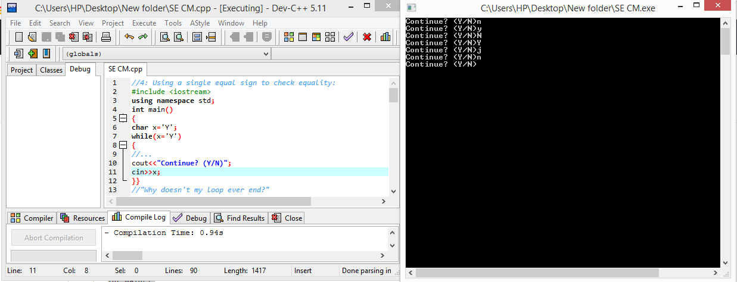

Ans: Because of using “=” operator instead of “==”.

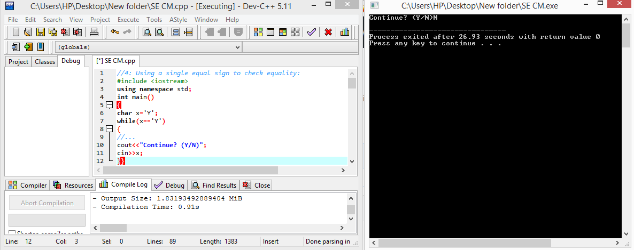

Q5: Undeclared Functions:

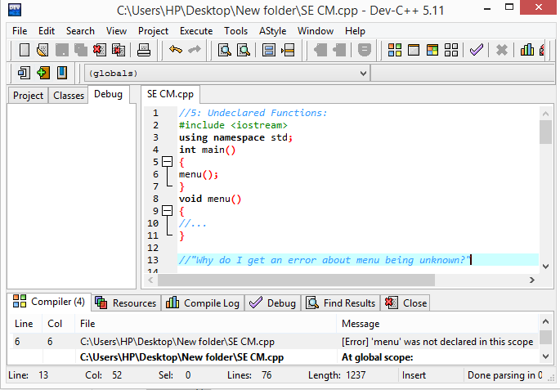

Ans: Because “menu” function was not declared.

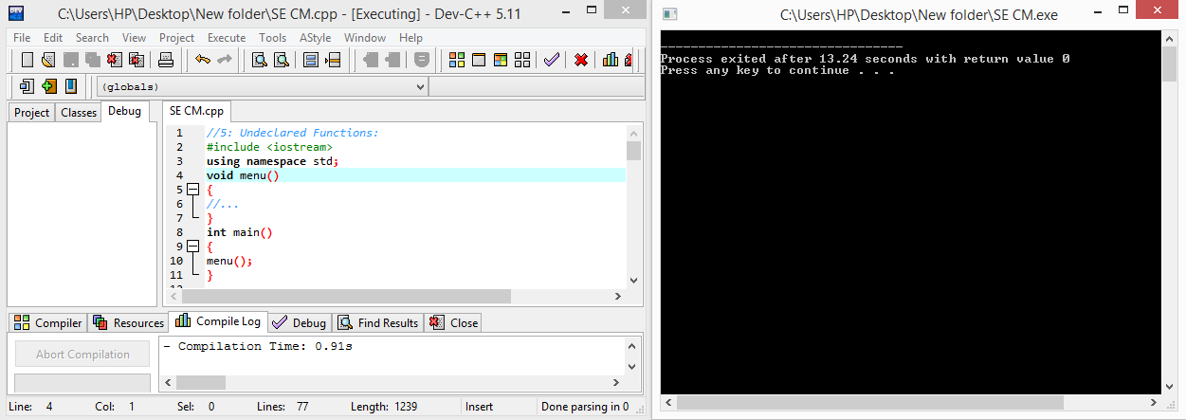

6: Extra Semicolons:

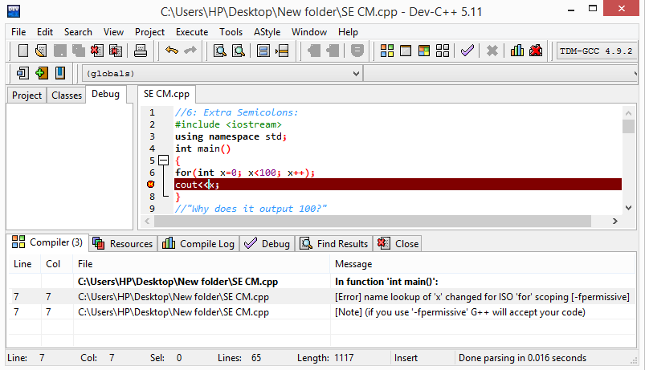

Ans: Because of semicolon in “for loop”.

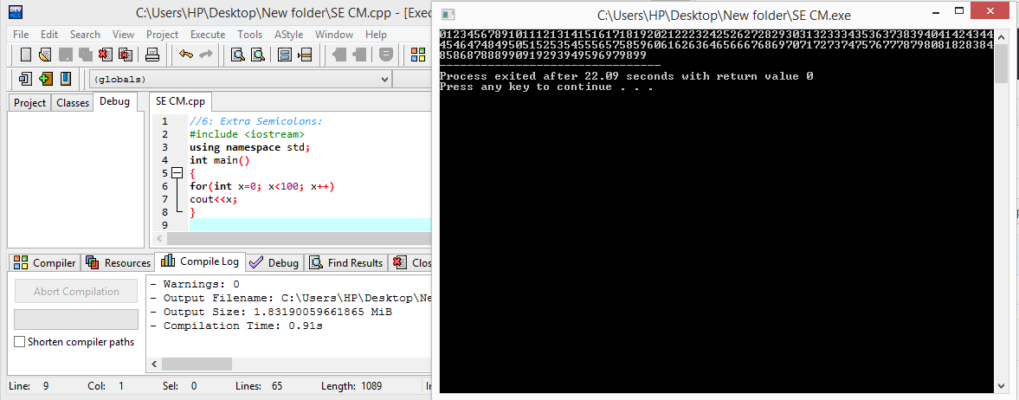

7: Overstepping array boundaries:

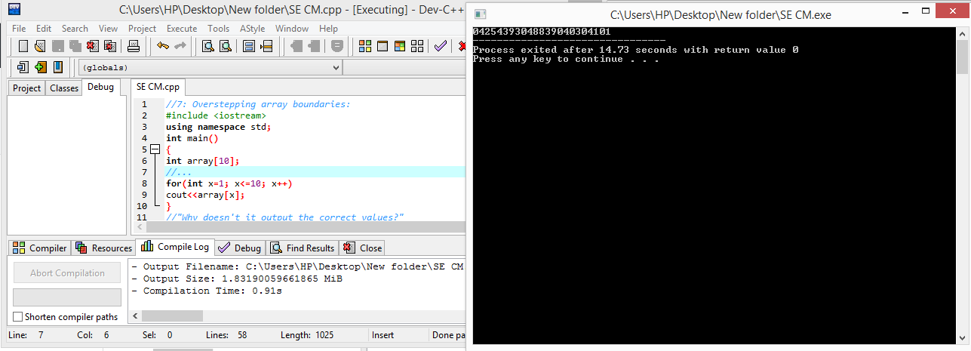

Ans: Array was not initialized and “x” was not set to “0”.

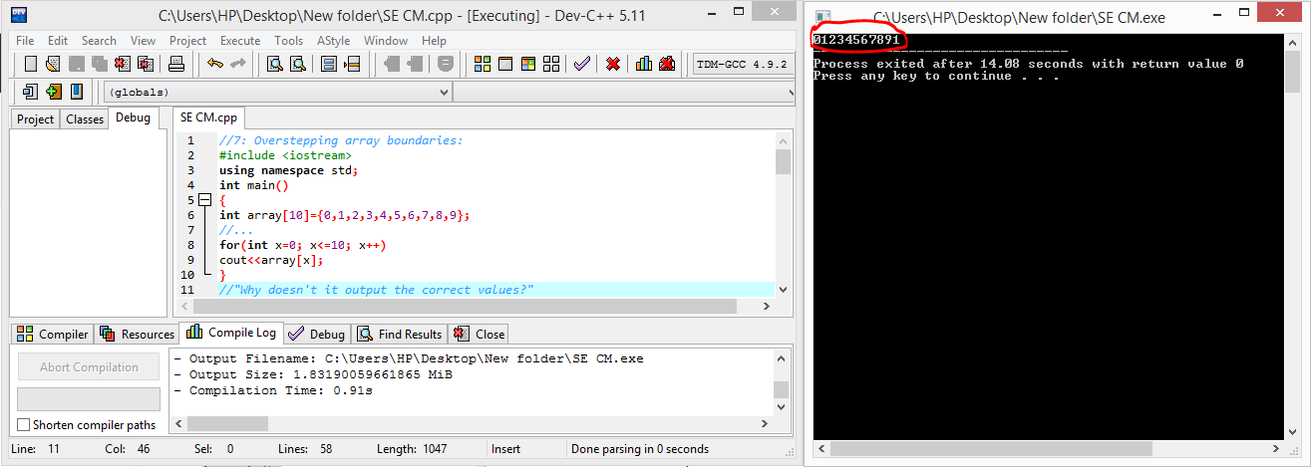

Ans: Using “X<=10” instead of “x<10”.

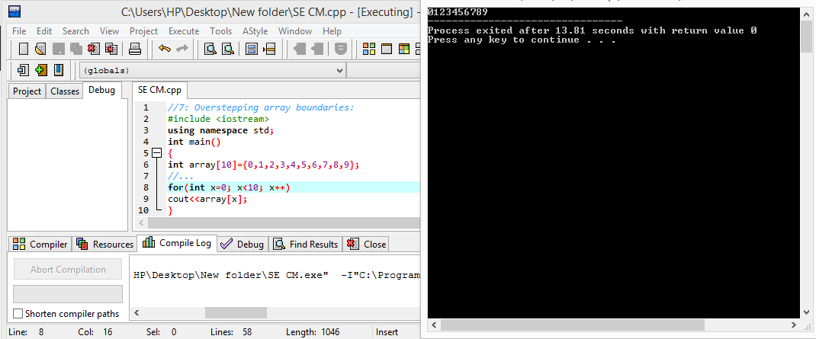

8: Integer division

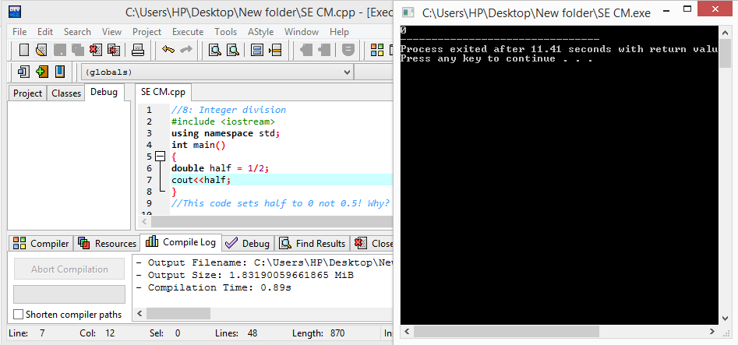

Ans: 1 and 2 are integer constant.Take 1.0 and 2.0.

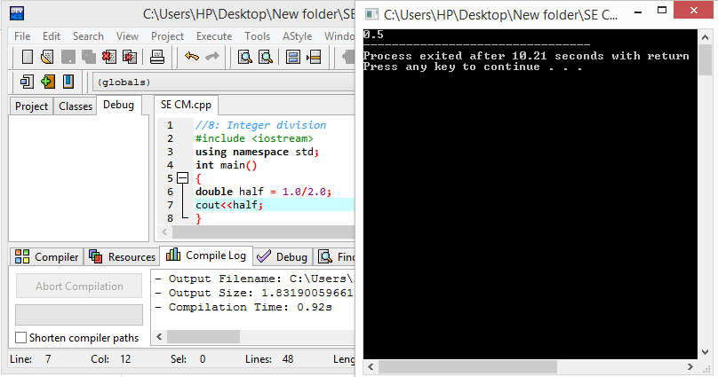

9: Variable Name Styles

Ans:It’s just copying the string character ratName to mypet.

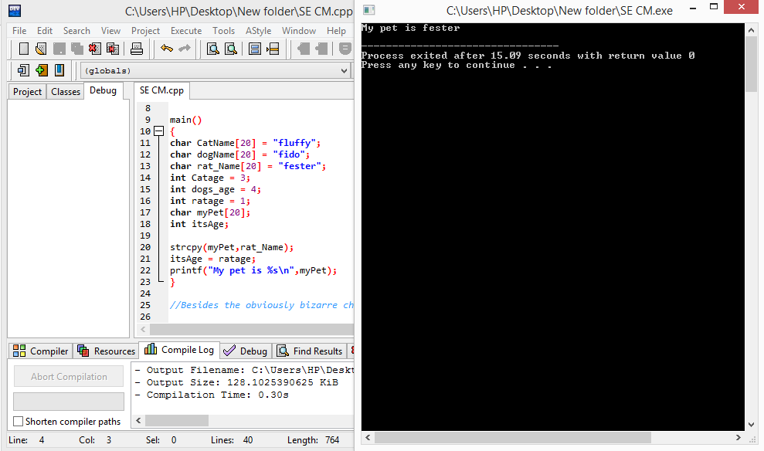

10 Misusing the && and || operators

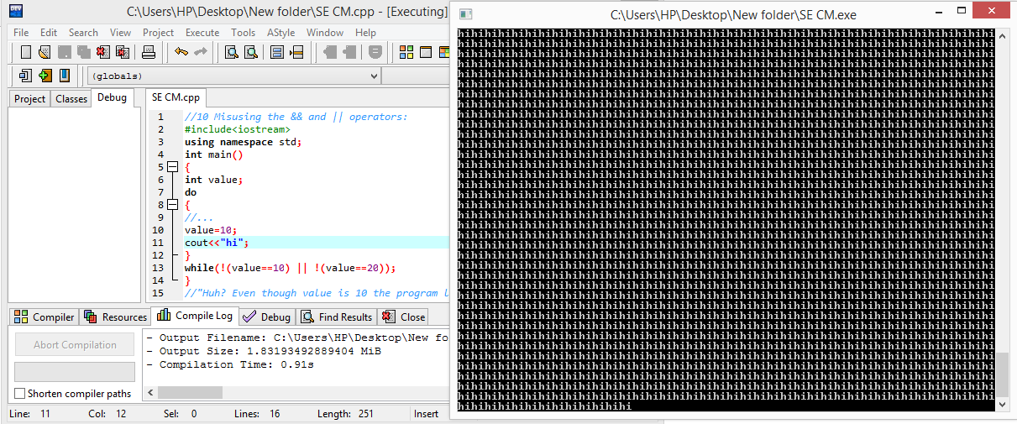

Ans:Using “||” operator instead of “&&”.

